Astronomy And Observation

# it’s more than what meets the eye…!

1. Astronomy starts with vision, not just because the use of optical instruments is a primary way to study the universe but also because to understand the universe, we need to see the universe.
2. Astronomy, life most other sciences starts with observing specific and unique patters in the universe. The patters give us a view of how things are functioning and in what way.
3. The first people who looked at the night sky were aware of patterns of stars, and they needed to navigate. So they named constellations. Constellations are still some of the most familiar features of the night sky. Obviously, it's hard to see literally people and animals in the night sky. These are mnemonics, as aids to navigation and understanding where people were on the surface of the earth.
4. Of all constellations observable in the night sky, of these, the 12 that circle the Zodiac, or the ecliptic, the region taken out by the motions of the sun has seen in the sky are the most important. **The 12 zodiacal constellations gave rise to astrology and star signs**. If you were ever lost on the earth's surface, you might find useful the idea of using constellations as navigation aids. And in fact in the ancient world, people were familiar with the constellations and used their appearance and disappearance throughout the year to judge when planting cycles and when navigation would take place, when expeditions were possible, and so on.

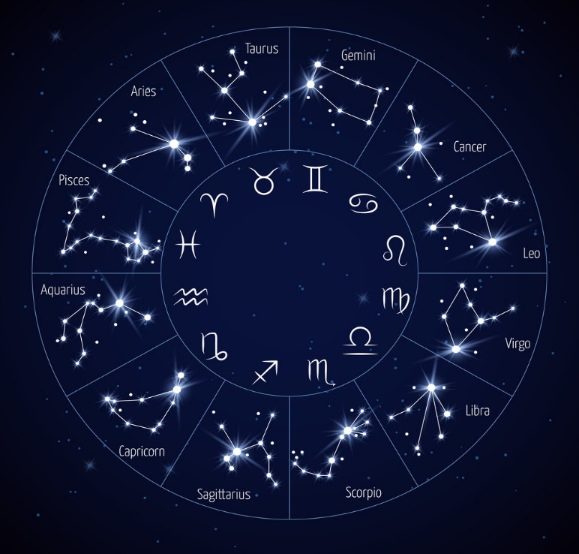

1. However constellations have no physical significance. They're patterns or asterisms of stars on the plane of the sky. Their significance of course now is primarily cultural and historical. And indeed, many myths and legends are embedded in the constellations, making for a rich lore in many of the world's cultures. In naked eye astronomy, and in general, we can think of the celestial sphere, even though our modern view of astronomy understands that the earth is moving around the sun, and that stars are very far away and at different distances. **The appearance of the celestial sphere as something that orbits the Earth every 24 hours is a useful construct for doing positional astronomy.**

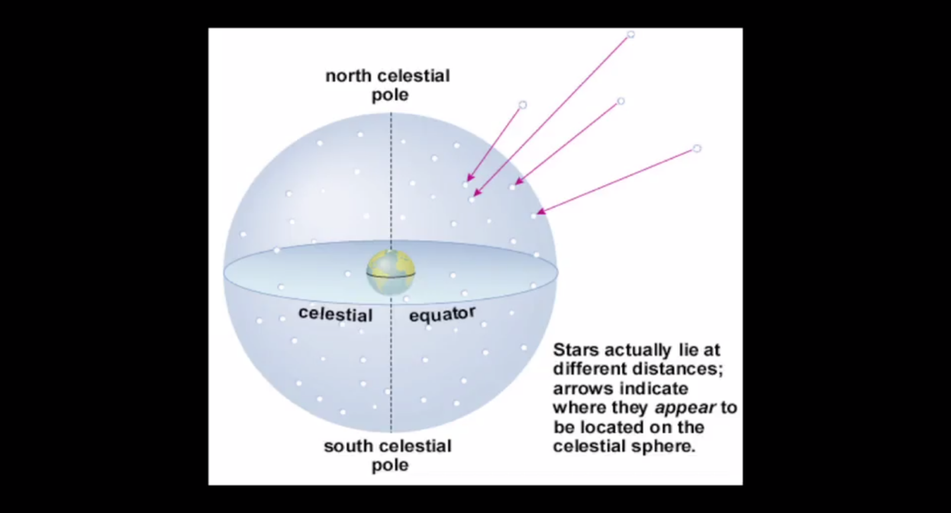

1. In positional astronomy, there are actually three coordinate systems or frames of reference that we may need to consider. One is indicated by the spinning Earth. That's what gives us the celestial poles and the celestial equator. The other is given by the ecliptic, which is the apparent path taken by the sun in the sky. Since the Earth is spinning like a top, with a tilt of 23.5 degrees relative to the plane of the Earth's sun orbit. The ecliptic is tilted by 23.5 degrees with respect to the celestial equator. A third frame of reference is given by the position of the Earth and the Sun within a larger context of the Milky Way. The Milky Way is in a disc-like system of stars where the plane of the disc is yet, yet a different angle than the celestial equator, or the ecliptic. This third frame of reference tells us where that band of stars, wheeling over head in the northern and southern sky lies, that's the plane of the galaxy we inhabit.

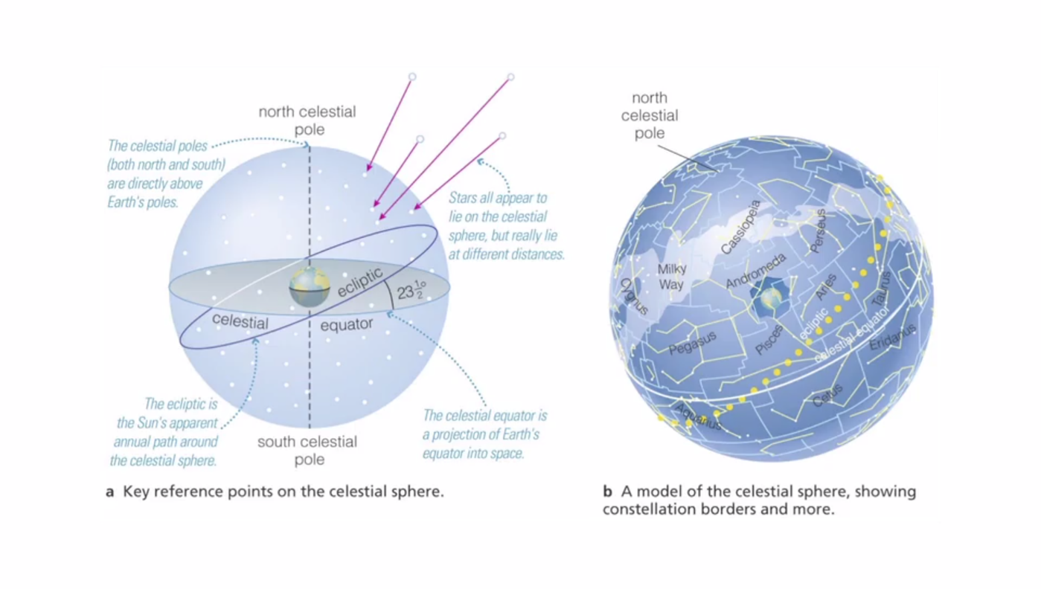

1. In positional astronomy, where the celestial sphere is the frame of reference, we can define the position of any star or any object in the night sky with two angles. Just as we can define a position on the Earth's surface by latitude and longitude. **Astronomers use two different frames of reference for measuring angles. The simplest is altitude and azimuth.** Altitude is the elevation directly going straight up from any horizon to the object of interest. And azimuth is the angle around the horizon from some fixed point like due north or due south. **Any point in the sky is defined by two unique angles of altitude and azimuth**. Professional astronomers use a different coordinate system based on measurements with respect to the ecliptic or the sun orbital plane. And those measurements are right ascension and declination, but the principle is the same. Any object in the sky is identifiable, uniquely, by two angles.
2. Here’s an important question that was asked profoundly during the *Copernican Revolution:*

*“How do we know that the earth is actually in motion around the sun rather than the other way around? Because from our perception, it appears that the night sky, are orbits over our head, the stars are on a celestial sphere, a cap over our heads orbiting once every 24 hours.”*

1. The relativity of this situation is actually quite profound. And it turns out, it was not for a few hundred years after the invention of the telescope that we proved that the Earth was moving around the sun. By a phenomena of stellar aberration, or starlight Is deflected slightly in its apparent path to the Earth by different amounts as the Earth moves around the sun in a year. Knowing the size of the Earth, we know how fast at any point on the Earth's surface we are moving. This speed is more than 1,000 miles at the equator. At a mid-latitude, it's a few hundred kilometers per second. And it's 0, of course, at the Poles.
2. There is a relatively bright star, Polaris, near the North Celestial Pole but no analogously bright star in the Southern hemisphere. Which is why Southern hemisphere navigators use the Southern cross and project the Southern cross several times its length towards the South Celestial Pole. Navigation just a little trickier in the Southern hemisphere than in the North. The Celestial Equator is the projection, in an imaginary sense, of the Earth's equator onto the celestial sphere. It's also significant that we can define two different days. **We can keep time by the sun or by the stars**. A Sidereal Day or a day kept time by the stars is four minutes shorter than a Solar Day. Due to the Earth's rotation, stars rise in the East and set in the West. Depending on our latitude, some stars are circumpolar or always appear in the night sky regardless of the time of year.
3. Some stars are invisible in some parts of the Earth's orbit. And some stars are invisible because they're in the other hemisphere of the Earth. If you think about it conceptually, if you're doing your observations from the North or South Pole, you'd be able to see the same 50% of the night sky over the course of a year. And the other 50% of the night sky would be always invisible to you. A Solar Day is the time it takes between one Earth orbit for the sun to appear overhead or at its highest elevation in the sky. **A Sidereal Day is the time it takes between an orbit of the Earth for a star to appear at its highest elevation in the sky.** When a star or the sun or any object it is at its highest elevation we call it its transit. If we think about the Earth and its orbit of the sun, then the Sidereal Day must be slightly shorter than a Solar Day, because that same star will appear fixed overhead while the Earth has moved about one degree in its orbital plane around the sun. Adding four minutes to a Solar Day compared to a Sidereal day. **The consequence of this is that any star rises or sets four minutes earlier every day. And over the course of the year, those four minutes of course add up to 360 degrees, or 24 hours. And so the whole cycle of the stars of the night sky cycles every 365 days**
4. The annual motion of the Earth around the Sun leads to a series of phenomena associated with the changing position and orientation of the sun as it transits in the sky. This information was of course common knowledge to all ancient cultures and tribes who used it to plan their lives, to plan crops, or to follow the sources of food that varied with the seasonal cycle. The orientation of the Sun in the sky changes because of the Earth's tilt as it spins about its axis. The spin axis is tilted by 23 and a half degrees with respect to the Earth's unorbital plane, or the ecliptic. In this series of time lapse photos taken from a northern latitude, even at mid-summer, the Sun rarely rises to high elevations. While at some parts of the year, the Sun never rises or sets at all.

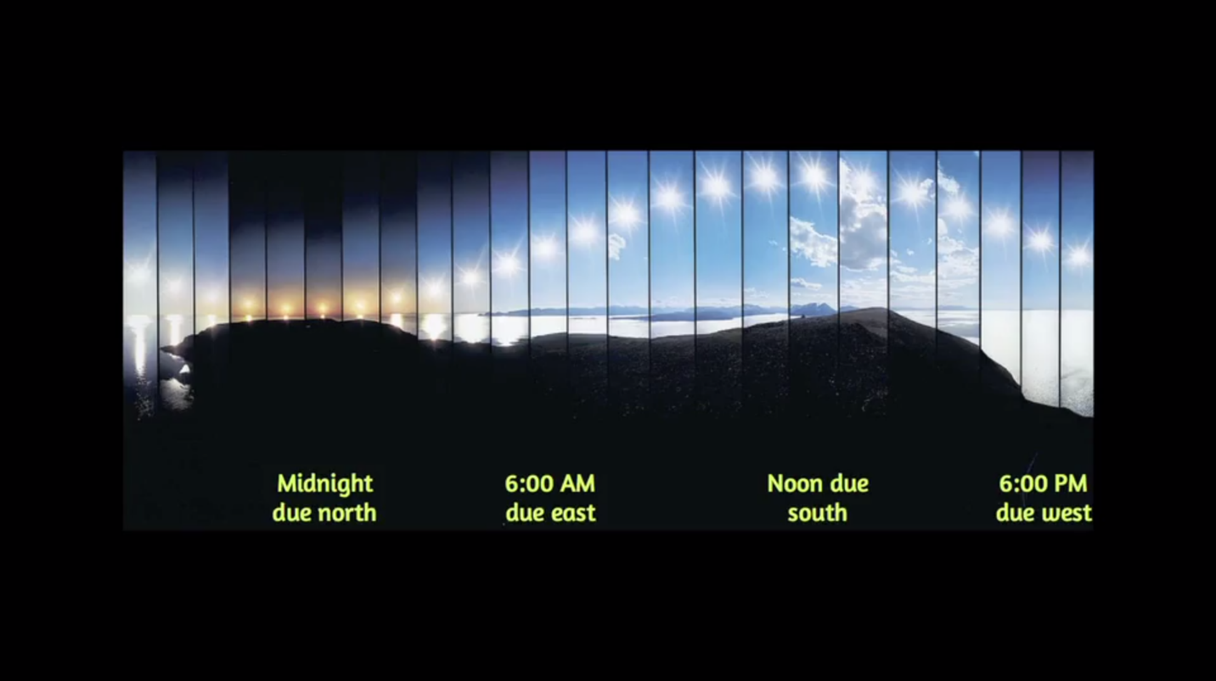

1. We've seen there are two planes, the one defined by the extension of the Earth's equator into the sky, the celestial equator, the second plane is that defined by the Earth-Sun orbit, or the ecliptic. These two planes are tilted by 23 and a half degrees, the tilt of the spin axis of the Earth. We define the equinoxes as the two points or times in the year when the ecliptic intersects the celestial equator. Those are the times, equinox meaning equal day and night, when night and day are equal in length. We define the solstices, summer and winter as the points where the ecliptic is furthest from the celestial equator. These define the highest and lowest elevations of the Sun in the annual cycle.

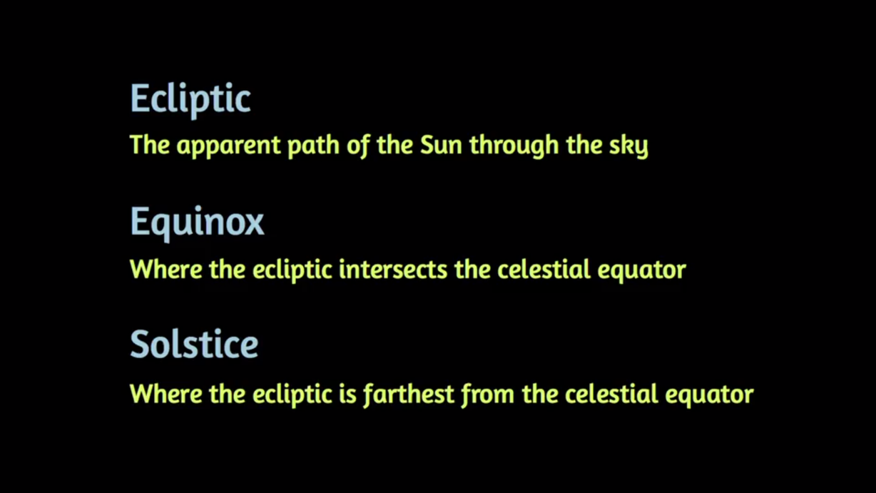

1. Because the Earth, tilted towards the Sun, presents a different face towards the stars in the night sky, 180 degrees opposite. And that position shifts through the constellations. A full cycle every 365 days. Meaning that any particular star rises or sets four minutes earlier each night. So the Earth's axis is tilted by 23 and a half degrees with respect to the ecliptic plane. The axis points roughly in the direction of Polaris in the Northern Hemisphere. Meaning that is our guiding sign post to due north when we're navigating on the Earth's surface. The second important consequence of the annual cycle is the seasonal variation. Seasons vary in different parts of the world. At equatorial and tropical latitudes, seasons are not marked. Sometimes there's only a dry season or a rainy season. But a temperate or mid-northern and southern latitudes, there's a clear, seasonal cycle and four distinct seasons.

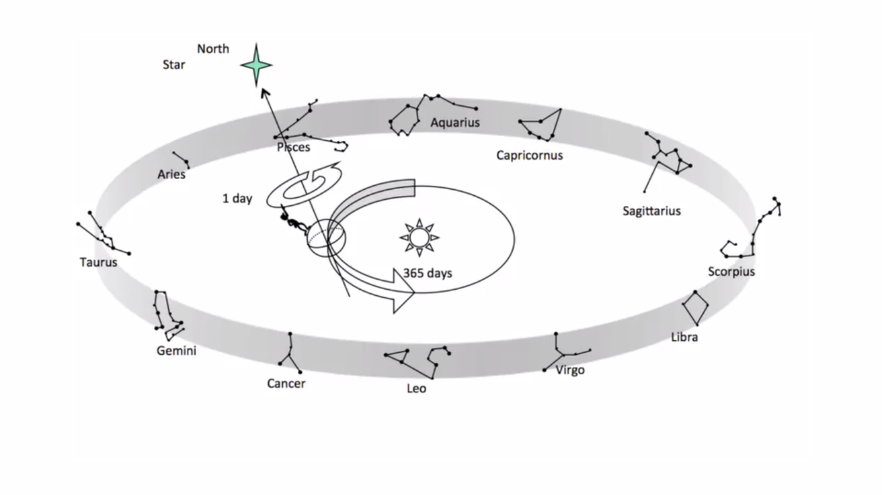

1. The seasonal cycle is caused by the tilt of the Earth's axis. Notice, however, that the seasonal cycle lags the actual tilt of the Earth. The summer solstice is June 21st, and on average in Northern Hemisphere, the hottest month is July or August. This lag of six months is caused by the buffering or blanketing effect of the Earth's atmosphere and oceans, which store heat and gradually leak it out. **This is quite a complex variation called the equation of time. And it's required to understand time keeping on the Earth.**
2. The solar year, or the time taken for the Earth to go from a fixed point in its orbit to the same position a year later, is not exactly 365 days, nor even 365 and a quarter. There's no reason it should be a round number and calendar making has been tied up in matching how we track time to this particular astronomical number. **The exact time for a solar year is 365 days, 5 hours, 48 minutes, and 45 seconds, slightly less than 365 and a quarter days**. The annual motion of the Earth around the Sun is based on a solar year, a number slightly less than 365 and a quarter days, and that's the basis of calendars and timekeeping.
3. At the northern latitudes, the Sun rises in the east and sets in the west, due east and west and the day and night are equal length. At the winter solstice, the Sun rises and sets south of due east and west, and the days are shorter than the nights and the reverse is true at the summer solstice. The seasonal cycle is also affected by the tilt of the Earth's axis, which in fact, causes the entire heating variation seen in northern and southern latitudes between summer and winter.
4. Other than the movement of the Earth alone, the movement of the moon is also of crucial importance to the Earth’s inhabitant condition. Lunar cycle is obvious to almost every position in the sky, and we don't even need a dark sky to see it. The phases of the moon occur over a lunar cycle, but we can measure the cycle in two distinct ways:

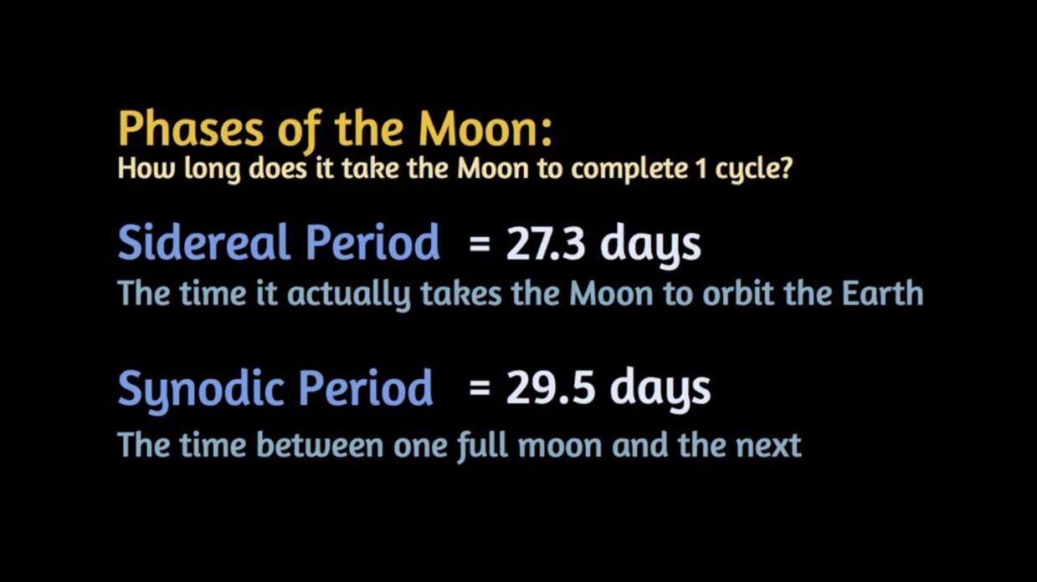

1. The moon revolves around the Earth and that generates the lunar cycle. While doing so, the moon goes through some phases when seen from the earth. **Interestingly, the new moon is not entirely dark. It receives a small amount of light from the Earth, called Earth-shine**. Another subtlety is added by the fact that the Earth's orbit of the Sun is tilted with respect to the Moon's orbit of the Earth by about four degrees. This means that when the Moon passes between the Sun and the Earth around a new moon, it rarely directly intersects the line between the Earth and the Sun.

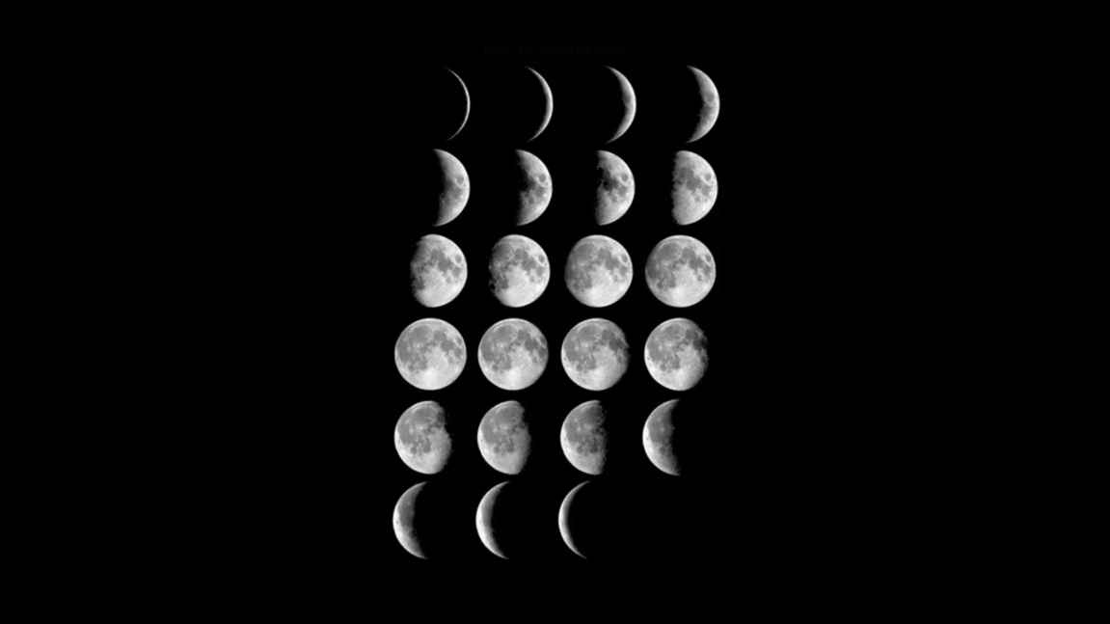

1. It also means that a full moon, the Sun is rarely on a line extending away from the Sun, in the opposite direction to the Earth. The tilt of the Moon-Earth orbit relative to the Earth-Sun orbit is what leads to the subtleties of eclipses. For a solar eclipse, the Moon must past directly between the Earth and the Sun, occulting the Sun and dimming its light and heat.
2. For a lunar eclipse, the Moon is on the opposite of the Earth to the Sun, and passes through the Earth's shadow, darkening what would otherwise be a full moon. We can see instinctively and intuitively that solar eclipses must be rarer than lunar eclipses. A solar eclipse will only occur when the Sun is directly occulted by the Moon and we happen to be on a position on the Earth's surface to be in the shadow, or umbra. However, a lunar eclipse occurs when the Earth casts its shadow over the entire Moon, and anyone on the night side of the Earth can see that**.**

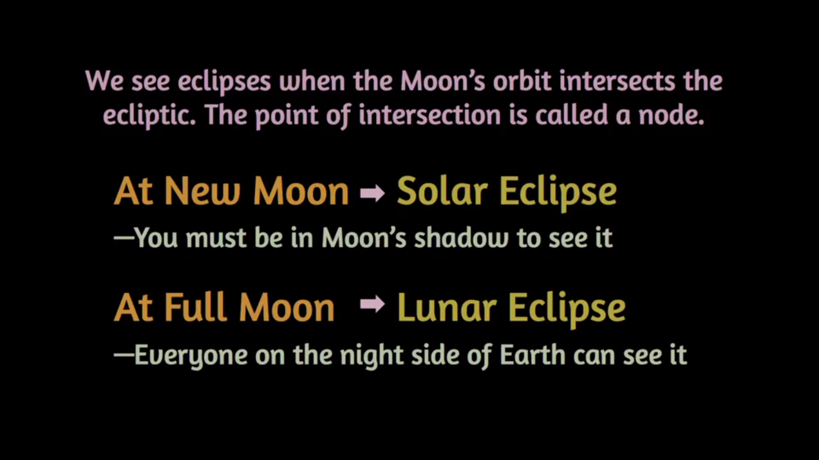

*The simplest statement to make about eclipses is that if the Earth, Sun had no tilt relative to the Earth-Moon axis, solar and lunar eclipses should occur every month.* **They do not because of this four degree tilt.**

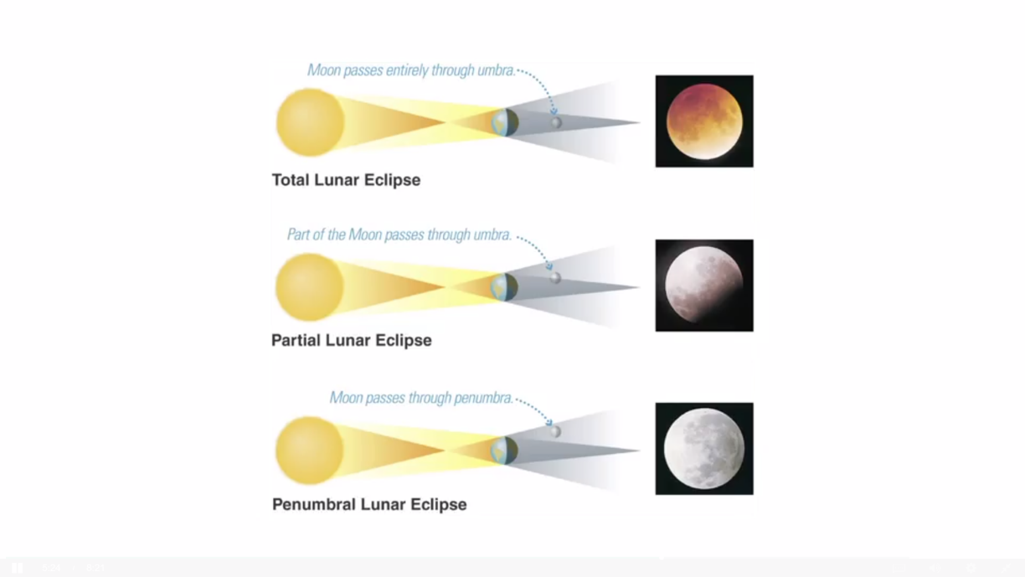

1. Occasionally, the Moon can overfill the disc of the Sun, completely blotting it out. And sometimes it underfills it, leading to an annular eclipse, or ring of light, around the Sun. The most spectacular solar eclipse occurs when the angular sizes are almost perfectly matched. And we see a ring of thin light, a diamond bead on a necklace around the edge of the Moon. The blotting out of the sunlight also allows us to see rare atmospheric phenomenon of the Sun, like the chromosphere and the corona. This graph or recent and upcoming solar eclipses shows how rare they are.

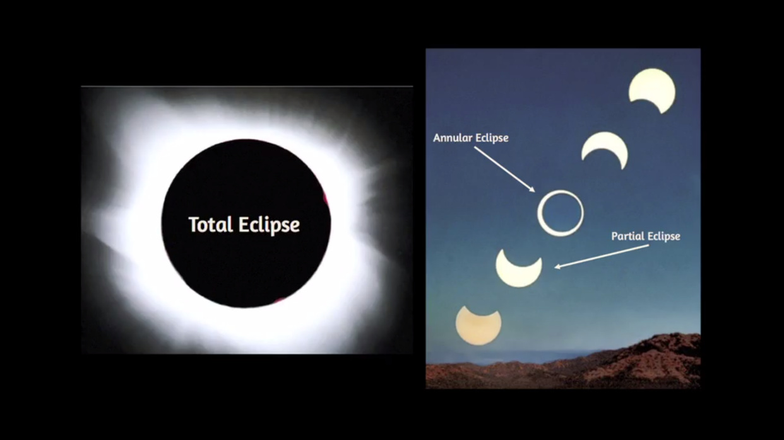

1. Beyond the sun, the moon and the stars in the night sky, the other dominant features of the sky are the planets. The word planet comes from the Greek word for wanderers. And the planets mark themselves out from the stars by moving with respect to the fixed constellations. They also don't twinkle, which means that they are physically resolved. And the discs of the planet are indeed visible to the naked eye.
2. The simplest distinction between planets is the so called inferior planets or those between us and the sun, Mercury and Venus. And the Superior Planets are those further out in their orbits from us than the sun, Mars, Jupiter and Saturn.

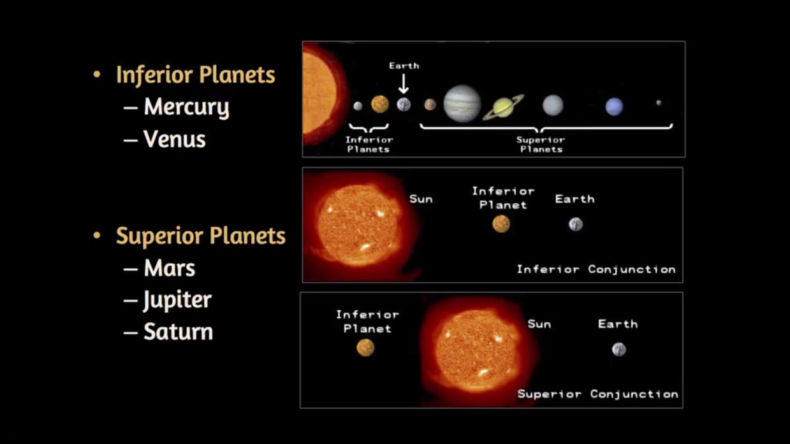

1. There are various pieces of terminology associated with observing planets:

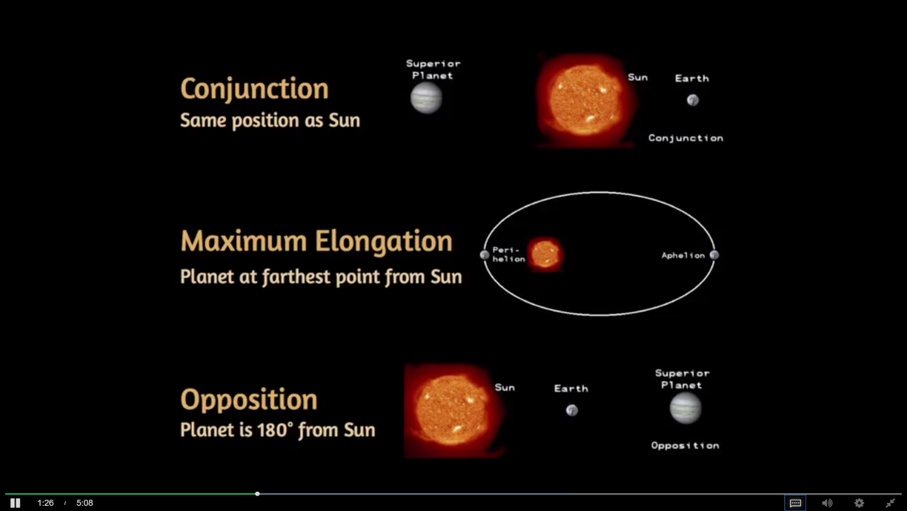

It is in conjunction, it's said to be near the Sun in the sky. When it's in opposition, it's said to be on the opposite side of the sky. We also define perihelion as a closest approach of a planet to the Sun in its orbit and aphelion as the furthest distance of a planet from the sun in its orbit.

1. Planets that are inferior, or closer to the sun than the earth, will always be seen relatively close to the sun in the sky. Whereas, planets that are exterior, or superior, can be seen at any location along the ecliptic depending on where they are in their orbits. For example, to observe Mercury is difficult because Mercury never gets more than about 15 degrees on either side of the Sun. It's always blinded by the Sun's light. The best way to see Mercury is when it appears just after sunset or just before sunrise. Venus, the brightest planet to the naked eye, is also relatively close to the Sun.

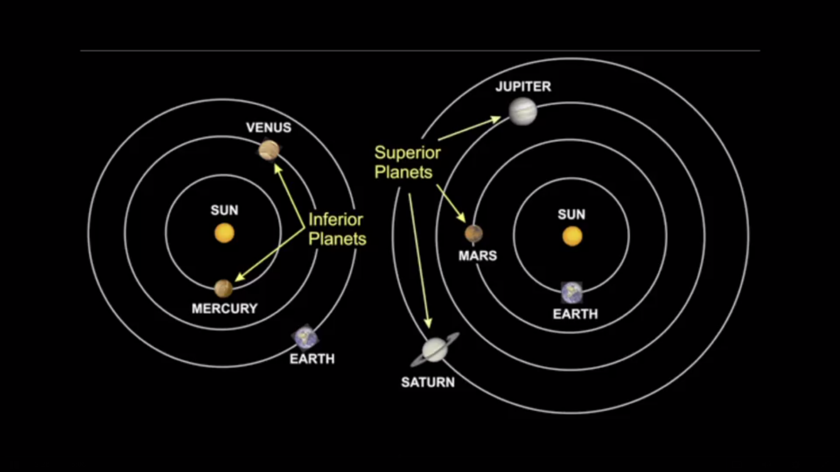

1. Mars and the outer planets, or superior planets, have a particular feature that marks them out, that of retrograde motion. As we've seen, retrograde motion of Mars was a determining feature in bringing on the Copernican revolution, the idea that the Earth was not the center of the universe. Retrograde motion is very difficult to explain if the Earth is immobile and all the planets go around the Earth. Because in a retrograde motion Mars appears to reverse its direction for several weeks in the fixed patter of the stars before recovering its forward motion. We can understand this fairly easily, because the Earth is moving faster on an interior orbit to Mars. And so occasionally, from the prospective of the Earth, we'll appear to overtake Mars, leading to its projection backwards in a motion against the fixed pattern of stars. The same effect can be seen with all the outer planets, but it's much more subtle and more difficult to observe.

***